MAKERERE UNIVERSITY
SCHOOL OF COMPUTING AND INFORMATION TECHNOLOGY
SOFTWARE REQUIREMENTS SPECIFICATION FOR RECESS FINAL PROJECT
An SRS submitted to the School of Computing and Informatics Technology
For the Study Leading to a Project Proposal in Partial Fulfillment of the
Requirements for the Award of the Degree of Bachelor of
Science in Software Engineering of Makerere University.

NAME | REG NO | STD. NO
KYAKA HERMAN CEASER | 15/U/6851/PS | 215011936
MALITI EMMANUEL | 17/U/5926/EVE | 217006711
KABWAMA RONALD | 15/U/5398/EVE | 215018454
KAIJUKA DONALD | 13/U/5658/PS | 213004661

Table of Contents
Contents
1. Introduction 2
1.1 Purpose 2
1.2 Product Scope 2
1.3 References 3
2. Overall Description 3
2.1 Product Perspective 3
2.2 Product Functions 3
2.3 Use Cases 4
2.3.1 Comment 4
2.3.2 Get Comment. 4
2.3.3 Read File. 4
2.3.4 Filter Data. 4
2.3.5 Preprocess Data. 4
2.3.6 Predict. 4
2.3.7 Display Results 4
2.4 Use Case Diagram 5
2.5 Detailed Use cases 6
2.5.1 Use case: FilterData 6
2.5.2 Usecase Preprocess. 6

Introduction

Purpose
To Create a Software Requirement Specification For a Review Prediction system. The system is to predict whether a comment given by a user is positive or negative.

Product Scope
For a given product, i.e a Movie, the customers will give a commentt to a particular movie and then the system is supposed to get the comments and it predicts whether the comment is positive or negative. The results are displayed as statistics which will help the product owner to improve on their Products or to make crucial Business Decisions.

References

Overall Description

Product Perspective
The system to be built is a new system that will operate in the backend of the client system or website. The model will get data from the client website through webscrapping and then operate on the data to predict the outcome. The prediction will be reflected to the client in form of visualization like barplots to show the number of positive and negative reviews.

Product Functions
The system must be able to collect data from the website.
The system must convert the data to a format that is readable by our model i.e csv
The system must Preprocess the data to remove unwanted features
The system must fit the processed data into the Machine learning model to get a prediction
The system must be able to display the results in form of visualizations.

Use Cases

Comment
The customers is the actor of this usecase. The customer should be able to comment on a particular Product.

Get Comment.
An Model is the Actor of this usecase. It will get comments from the website and saves them into a csv file.

Read File.
The use case is responsible for parsing data from the file. The actor if this usecase is the Model

Filter Data.
The use case is responsible for filtering the data and removing unwanted features and dealing with missing Data.

Preprocess Data.
The use case is responsible for formatting text into a format that is acceptable by the machine learning Algorithm. Tokenizing, and count vectorization takes place in this use case.

Predict.
The use case is supposed to take the preprocessed data and apply the algorithm onto it to predict the class of the review whether its positive or negative.

Display Results
The usecase is supposed to display the predictions onto a graph. The Client is the actor for this use case

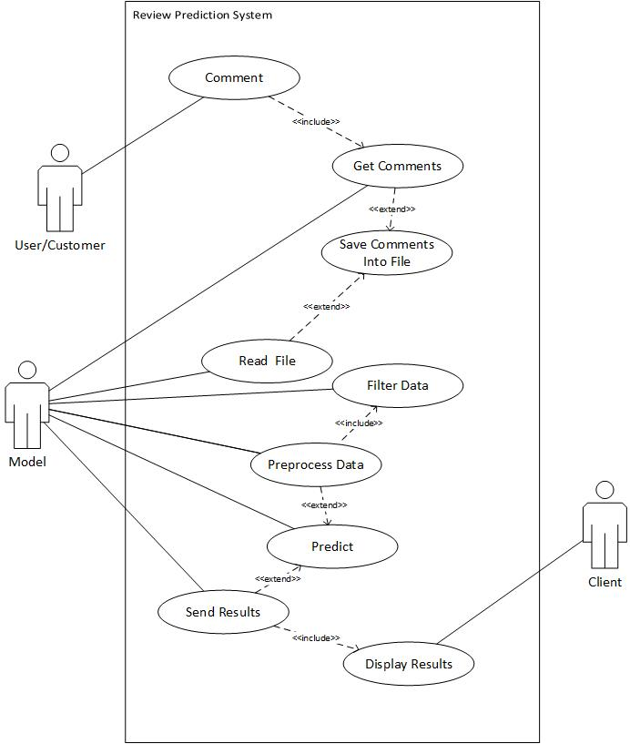
Use Case Diagram

Detailed Use cases

Use case: FilterData
Title: | Filter Data
Actors | Model.
Precondition | When file is read into a data Frame
Steps | The usecase starts when data file is read into memory.  The data is read as a dataframe and unwanted features are removed.  All the missing values are replaced
Post condition | Data should be clean and have no missing values

Usecase Preprocess.
Title: | Preprocess
Actors | Model.
Precondition | Data should have no missing values
Steps | The usecase starts when data is filtered.  The Model removes English punctuation and stop words using Natural language Processing algorithms.  It then creates a list of no processed text.
Post condition | Data should have no stopwords.

